Sal f
Golden Valley High School
Wm. S. Hart Union High School District
“Home of the Grizzlies”
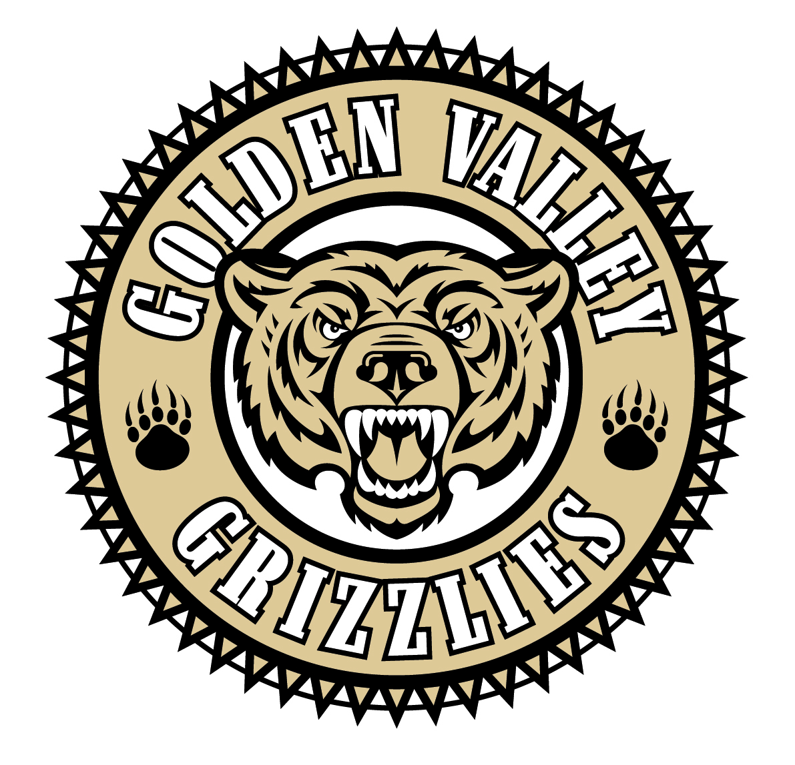
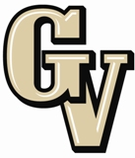

Parent Advisory Council (PAC) Meeting
August 26, 2013
6:30 PM

AGENDA

- PAC Meeting Welcome Sal Frias

- Secretary’s Report ACTION Jennifer Ryan

- Treasurer’s Report ACTION Emily Curtis

- President’s Report Sue Alterman

- District Advisory Council (DAC) Report Monica Camacho

- Parent Communications Council (PCC) Report Cherise Moore

- Circle of Friends Joel Nelson

- Big History Project Kate Povletich/Kari Irvin

- Common Core Update Sal Frias

- 2012-13 STAR Test Results Sal Frias

Announcements: -College Bound Strategies Workshop, August 27th
-Hispanic College and Career Night on Thursday, August 29th
-District Min. Day on Wednesday, September 4th
-ASB Food Fest #1 on Wednesday, September 18th

Next Meeting: September 23, 2013

The mission of GVHS is to provide a quality education to a diverse student population, develop each student’s maximum potential, and prepare students for success in the global community.

